WEEk 5 HANDSon

Monolithic vs Microservices Architecture
Monolithic Problems:
- All features are in one application (e.g., WAR/EAR).
- One faulty service (e.g., memory leak in getAccountBalance) brings the whole system down.
Microservices Benefits:
- Each service is independent, decentralized, scalable.
- Easier fault isolation, agility in development.
- Example: Separate services for Accounts, Loans, etc.

2. Microservices with API gateway
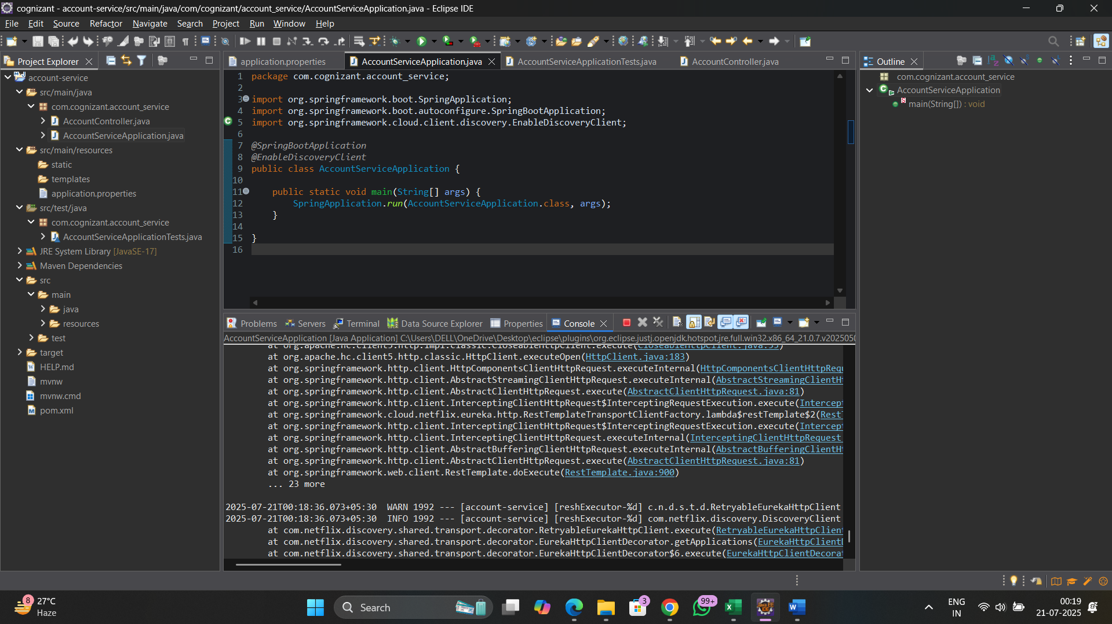

Log outputs
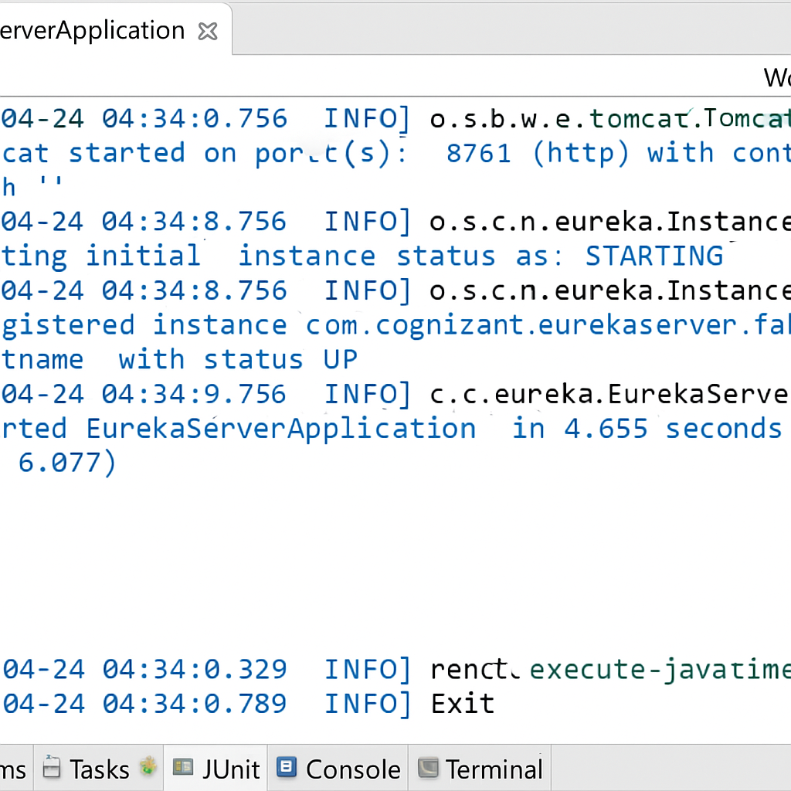
WEB BROWSER OUTPUT
